|  |  |  |  |  |
| --- | --- | --- | --- | --- |
|  |  | | |  |
| **Huawei FusionDirector for SCOM Plug-in**  **V1.0.15** | | |
| **User Guide** | | |
| **Issue** | **01** | |
| **Date** | **2020-05-06** | |
|  | | | | |
|  | HUAWEI TECHNOLOGIES CO., LTD. | |  |  |

|  |
| --- |
| **Copyright © Huawei Technologies Co., Ltd. 2020. All rights reserved.**  No part of this document may be reproduced or transmitted in any form or by any means without prior written consent of Huawei Technologies Co., Ltd.  **Trademarks and Permissions**  and other Huawei trademarks are trademarks of Huawei Technologies Co., Ltd.  All other trademarks and trade names mentioned in this document are the property of their respective holders.  **Notice**  The purchased products, services and features are stipulated by the contract made between Huawei and the customer. All or part of the products, services and features described in this document may not be within the purchase scope or the usage scope. Unless otherwise specified in the contract, all statements, information, and recommendations in this document are provided "AS IS" without warranties, guarantees or representations of any kind, either express or implied.  The information in this document is subject to change without notice. Every effort has been made in the preparation of this document to ensure accuracy of the contents, but all statements, information, and recommendations in this document do not constitute a warranty of any kind, express or implied. |

|  |  |
| --- | --- |
| Huawei Technologies Co., Ltd. | |
| Address: | Huawei Industrial Base  Bantian, Longgang  Shenzhen 518129  People's Republic of China |
| Website: | <https://e.huawei.com> |
|  |  |

About This Document

Purpose

This document describes how to install and uninstall the Huawei SCOM plug-in, add and delete FusionDirector, and view Huawei server information and status, alarm lists, and server topologies by using FusionDirector For SCOM Plugin.

Intended Audience

This document is intended for:

* Technical support engineers
* System maintenance engineers

Symbol Conventions

The symbols that may be found in this document are defined as follows.

| Symbol | Description |
| --- | --- |
|  | Indicates an imminently hazardous situation which, if not avoided, will result in death or serious injury. |
|  | Indicates a potentially hazardous situation which, if not avoided, could result in death or serious injury. |
|  | Indicates a potentially hazardous situation which, if not avoided, may result in minor or moderate injury. |
|  | Indicates a potentially hazardous situation which, if not avoided, could result in equipment damage, data loss, performance deterioration, or unanticipated results.  NOTICE is used to address practices not related to personal injury. |
|  | Calls attention to important information, best practices and tips.  NOTE is used to address information not related to personal injury, equipment damage, and environment deterioration. |

Change History

Changes between document issues are cumulative. The latest document issue contains all the changes made in earlier issues.

| Issue | Date | Description |
| --- | --- | --- |
| 01 | 2020-05-06 | This issue is the first official release. |

Contents

About This Document ii

1 Overview 1

2 Installing and Uninstalling the Huawei SCOM Plug-in 2

2.1 Installing the Huawei SCOM Plug-in 2

2.2 Uninstalling the Huawei SCOM Plug-in 10

3 Configuring FusionDirector 16

3.1 Adding FusionDirector 16

3.2 Editing FusionDirector 20

3.3 Deleting FusionDirector 22

4 Viewing Plug-in System Information 24

4.1 Viewing the Basic Plug-in System Information and Status 24

4.2 Viewing a Plug-in System Event List 26

4.3 Viewing a Plug-in System Alarm List 28

5 Viewing Chassis Information 30

5.1 Viewing the Basic Chassis Information and Status 30

5.2 Viewing a Chassis Topology 33

5.3 Viewing a Chassis Alarm List 35

6 Viewing Server Information 37

6.1 Viewing the Basic Server Information and Status 37

6.2 Viewing a Server Topology 39

6.3 Viewing a Server Alarm List 40

6.4 Viewing Server Performance Curves 42

6.4.1 Viewing the CPU Usage 42

6.4.2 Viewing the Air Inlet Temperature 43

6.4.3 Viewing the PSU Power 43

7 FAQs 45

7.1 How Do I Fix a Communication Failure Caused by an Incorrect Default FusionDirector Certificate? 45

7.2 How Do I Replace the Server Certificate? 54

A Glossary 66

# Overview

The Huawei SCOM plug-in is a plug-in integrated in the System Center Operations Manager (SCOM for short) software and used for Huawei server management. By adding FusionDirector, it can monitor the health status and alarm information of Huawei servers. A maximum of 1000 servers can be monitored. Table 1-1 lists the servers supported by the Huawei SCOM plug-in.

You can implement the following functions by using the Huawei SCOM plug-in:

* View the information of servers and chassis.
* View the health status of servers and chassis.
* View the alarm information of servers and chassis.
* View the topologies of servers and chassis.
* View the performance curves of servers.

Supported servers

| Type | Server |
| --- | --- |
| Server | 1288H V5 |
| 2288 V5 |
| 2288H V5 |
| 2488 V5 |
| 2488H V5 |
| CH121 V3 |
| CH242 V3 |
| CH121 V5 |
| CH242 V5 |
| RH2288H V3 |
| Chassis | E9000 (MM920) |

# Installing and Uninstalling the Huawei SCOM Plug-in

2.1 Installing the Huawei SCOM Plug-in

2.2 Uninstalling the Huawei SCOM Plug-in

## Installing the Huawei SCOM Plug-in

Prerequisites

* SCOM 2012 R2, SCOM 2016, or SCOM 2019 has been installed on the SCOM server.

The following uses SCOM 2012 R2 as an example.

* .Net Framework 4.0 or later has been installed on the SCOM server.

Procedure

Download the Huawei SCOM plug-in installation package of the latest version from the [GitHub](https://github.com/Huawei/Huawei_FusionDirector_For_SCOM/tree/master/release) website, for example, **Huawei_FusionDirector_For_SCOM_Plugin_*x.x.xx.xxx*.zip**.

Upload the Huawei SCOM plug-in installation package to the SCOM server.

Log in to the SCOM server.

Decompress the Huawei SCOM plug-in installation package.

Obtain the installation application, for example, **Huawei_FusionDirector_For_SCOM_Plugin_*x.x.xx.xxx*.exe**.

Double-click **Huawei_FusionDirector_For_SCOM_Plugin_*x.x.xx.xxx*.exe**.

The **Installer Language** window is displayed, as shown in Figure 2-1.

Installer Language

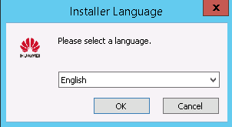

Select **English**, and click **OK**.

The welcome to the setup wizard window is displayed, as shown in Figure 2-2.

Welcome to the setup

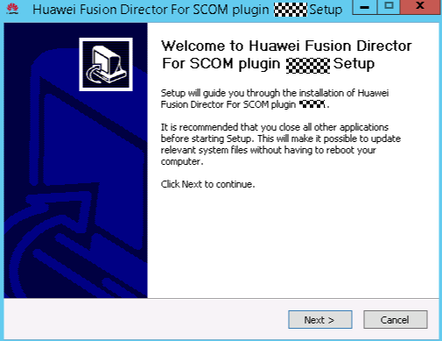

Click **Next**.

The **Choose Install Location** window is displayed, as shown in Figure 2-3.

Choose Install Location

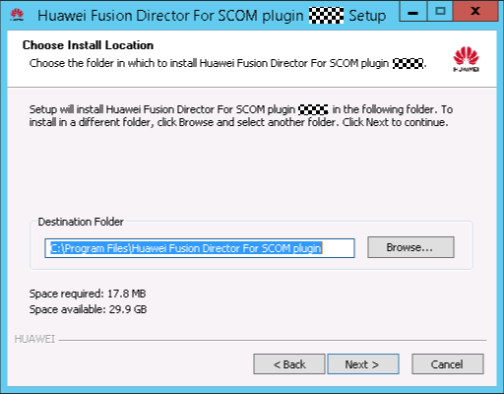

Retain the default installation path or click **Browse** to change the installation path, and click **Next**.

The **Select features to install** window is displayed, as shown in Figure 2-4.

Select features to install

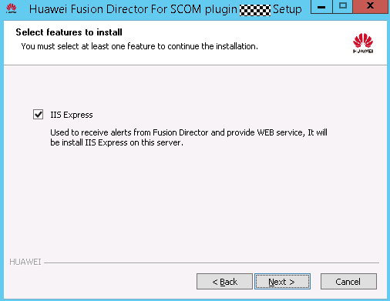

**IIS Express** is selected by default. Click **Next**.

The **IP/Port Configuration** window is displayed, as shown in Figure 2-5.

IP/Port Configuration

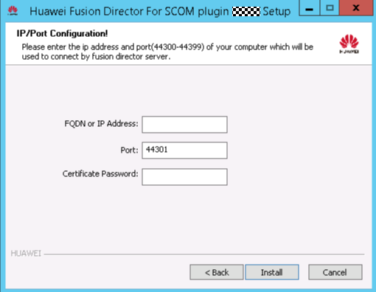

Enter the FQND or IP address, port number and certificate password of the SCOM server that is used to connect to FusionDirector. Click **Install**.



* The port number ranges from 44300 to 44399. You are advised to retain the default value **44301**.
* Default certificate password is **Huawei12#$**.

The Huawei SCOM plug-in installation starts, as shown in Figure 2-6.

Installing the Huawei SCOM plug-in

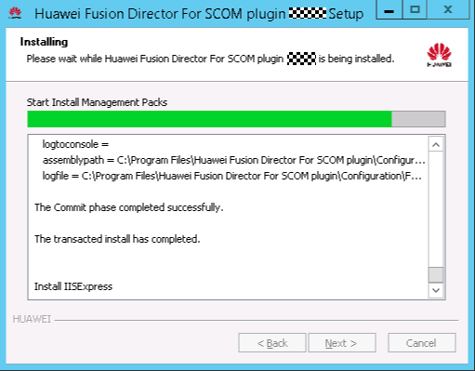

After the installation is complete, the completing the setup wizard is displayed, as shown in Figure 2-7.

Completing the setup

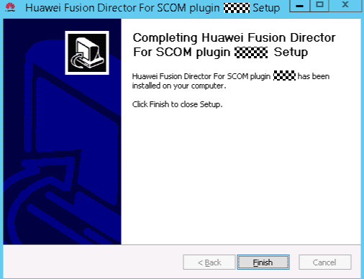

Click **Finish**.

The Huawei SCOM plug-in installation is complete.

Choose **Start** > > **Operations Console**.



The SCOM main window is displayed, as shown in Figure 2-8.

SCOM main window

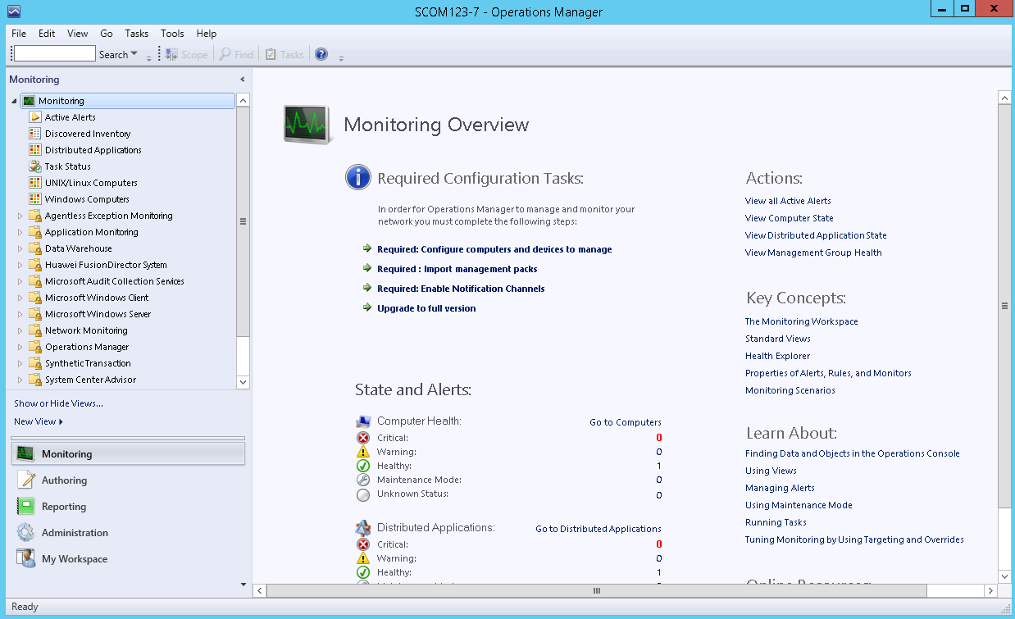

Choose **Administration** > **Management Packs**.

The **Management Packs** window is displayed, as shown in Figure 2-9.

Management Packs

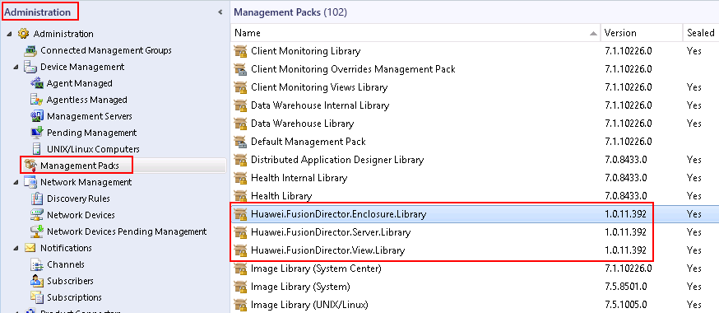

After the Huawei SCOM plug-in is successfully installed, the Manage Package (MP) packages in the red box are displayed in the **Management Packs** window.

After the MP packages are successfully installed, the nodes in the red box are displayed in the SCOM main window, as shown in Figure 2-10.

SCOM main window

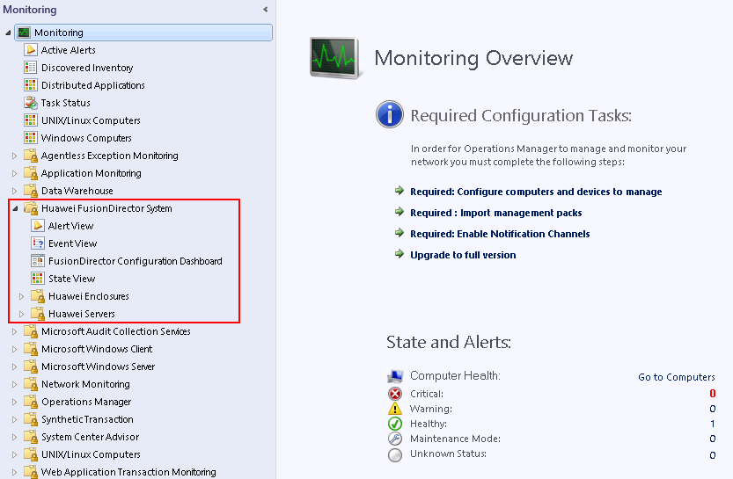

----End

## Uninstalling the Huawei SCOM Plug-in

Prerequisites

You need to close the SCOM window before uninstalling the Huawei SCOM plug-in.

Uninstalling the Huawei SCOM Plug-in from the Control Panel

Choose **Start** > **Control Panel** > **Programs and Features** > **Uninstall a program**.

The **Uninstall or change a program** window is displayed, as shown in Figure 2-11.

Uninstall or change a program

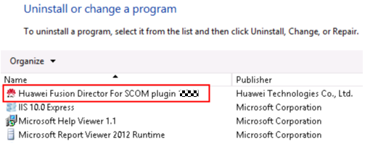

Double-click the Huawei SCOM plug-in (for example, **Huawei Fusion Director For SCOM plugin x.x.xx**).

A confirmation dialog box is displayed, as shown in Figure 2-12.

Dialog box

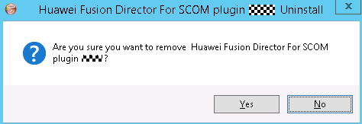

Click **Yes**.

The dialog box asking you whether to uninstall IIS Express is displayed, as shown in Figure 2-13.

Dialog box

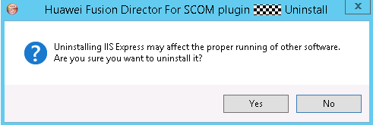

* IIS Express is responsible for the communication between the plug-in and FusionDirector. Uninstalling IIS Express may affect the proper running of other software. Exercise caution when performing this operation.
* If you uninstall IIS Express, it will be reinstalled when you install the Huawei SCOM plug-in again.
* If IIS Express needs to be uninstalled, click **Yes**.
* If IIS Express does not need to be uninstalled, click **No**.

Click **Yes** or **No**.

The Huawei SCOM plug-in uninstallation starts, as shown in Figure 2-14.

Uninstalling the Huawei SCOM plug-in

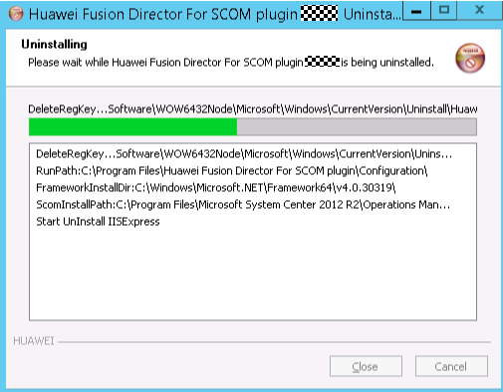

After the uninstallation is complete, the dialog box shown in Figure 2-15 is displayed.

Uninstallation completed

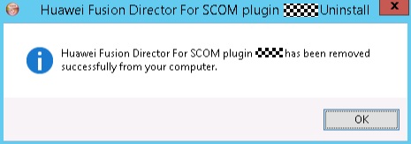

Click **OK**.

The Huawei SCOM plug-in is uninstalled.

----End

Uninstalling the Huawei SCOM Plug-in from the Installation Directory

Go to the installation directory of the Huawei SCOM plug-in (**C:\Program Files\Huawei Fusion Director For SCOM plugin** by default), as shown in Figure 2-16.

Installation directory of the Huawei SCOM plug-in

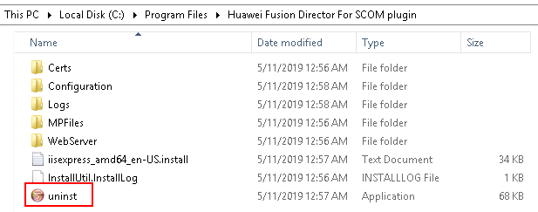

Double-click **uninst**.

A confirmation dialog box is displayed, as shown in Figure 2-17.

Dialog box

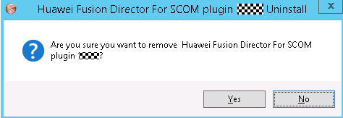

Click **Yes**.

The dialog box asking you whether to uninstall IIS Express is displayed, as shown in Figure 2-18.

Dialog box



* IIS Express is responsible for the communication between the plug-in and FusionDirector. Uninstalling IIS Express may affect the proper running of other software. Exercise caution when performing this operation.
* If you uninstall IIS Express, it will be reinstalled when you install the Huawei SCOM plug-in again.
* If IIS Express needs to be uninstalled, click **Yes**.
* If IIS Express does not need to be uninstalled, click **No**.

Click **Yes** or **No**.

The Huawei SCOM plug-in uninstallation starts, as shown in Figure 2-19.

Uninstalling the Huawei SCOM plug-in



After the uninstallation is complete, the dialog box shown in Figure 2-20 is displayed.

Uninstallation completed



Click **OK**.

The Huawei SCOM plug-in is uninstalled.

----End

# Configuring FusionDirector

3.1 Adding FusionDirector

3.2 Editing FusionDirector

3.3 Deleting FusionDirector

## Adding FusionDirector



A maximum of 10 FusionDirector instances can be added.

Choose **Start** > > **Operations Console**.



The SCOM main window is displayed, as shown in Figure 3-1.

SCOM main window



Choose **Monitoring** > **Huawei FusionDirector System** > **FusionDirector Configure View**.

The **FusionDirector Configure Dashboard** window is displayed, as shown in Figure 3-2.

FusionDirector Configure Dashboard

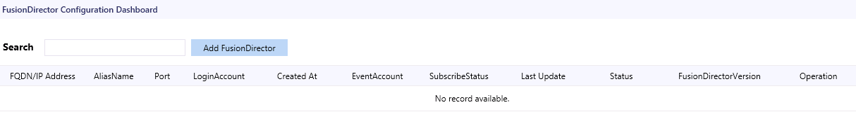

Click **Add FusionDirector**.

The **Add FusionDirector** dialog box is displayed, as shown in Figure 3-3.

Add FusionDirector

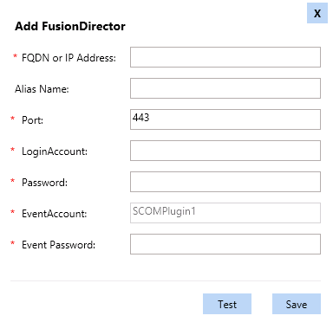

Table 3-1 describes the parameters in this dialog box.

Parameter description

| Parameter | Description | Value | Mandatory |
| --- | --- | --- | --- |
| FQDN or IP Address | FQDN or IP address of FusionDirector. | The IP address format is XXX.XXX.XXX.XXX. Each X must be an integer. | Yes |
| Alias Name | Customized FusionDirector name. | The value is a string of 1 to 100 characters, including letters, digits, underscores (_), hyphens (-), and dots (.). | No |
| Port | FusionDirector port number. | The default value is **443**. | Yes |
| LoginAccount | FusionDirector user name. | The default value is **rootRedfish**. | Yes |
| Password | FusionDirector password. | The default value is **Machine@123**. | Yes |
| Event Account | Alarm service account. | The value is automatically generated by the system. | Yes |
| Event Password | Alarm service password. | The password contains 8 to 32 characters, including uppercase letters, lowercase letters, digits, and special characters.  Special characters include '~!@$%^&*()-_=+|[{}];:'"",<>/?. | Yes |

Enter FusionDirector information, and click **Test** to test whether the SCOM server can connect to FusionDirector.

If the test is successful, "Connect successful" is displayed, as shown in Figure 3-4. If the test fails, the failure cause is displayed. Modify FusionDirector information as prompted.

Successful test

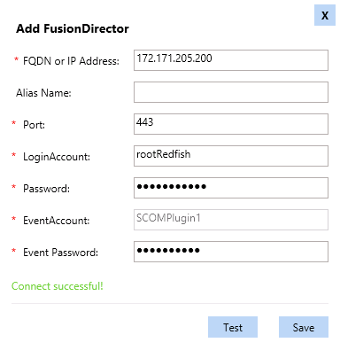

Click **Save**.

The FusionDirector is added successfully, as shown in Figure 3-5.

FusionDirector added successfully

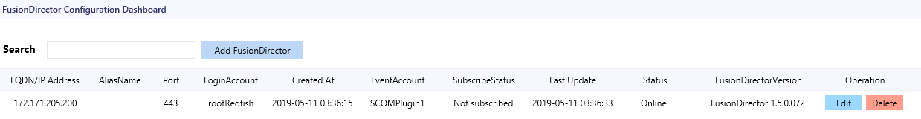

----End

## Editing FusionDirector

Choose **Start** > > **Operations Console**.



The SCOM main window is displayed, as shown in Figure 3-6.

SCOM main window



Choose **Monitoring** > **Huawei FusionDirector System** > **FusionDirector Configure Dashboard**.

The **FusionDirector Configure Dashboard** window is displayed, as shown in Figure 3-7.

FusionDirector Configure Dashboard



If the FusionDirector information is empty, no FusionDirector is added.

In the **Operation** column, click Edit.

The **Edit FusionDirector** dialog box is displayed, as shown in Figure 3-8.

Edit FusionDirector

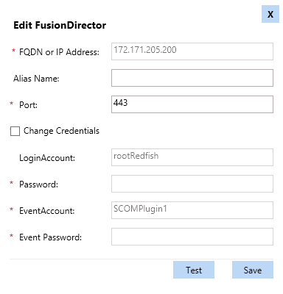

Edit the FusionDirector information according to Table 3-1, and click **Save**.



* The FusionDirector IP address cannot be modified.
* You can change the FusionDirector user name and password only after selecting **Change Credentials**. After changing the user name and password, click **Test**.

The FusionDirector is successfully edited, as shown in Figure 3-9. In this window, you can check whether the modified information is consistent with the target.

Modified FusionDirector information

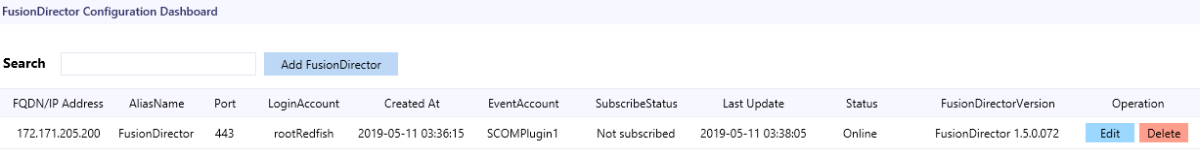

----End

## Deleting FusionDirector

Choose **Start** > > **Operations Console**.



The SCOM main window is displayed, as shown in Figure 3-10.

SCOM main window



Choose **Monitoring** > **Huawei FusionDirector System** > **FusionDirector Configure Dashboard**.

The **FusionDirector Configure Dashboard** window is displayed, as shown in Figure 3-11.

FusionDirector Configure Dashboard



If the FusionDirector information is empty, no FusionDirector is added.

In the **Operation** column, click **Delete**.

The **Delete FusionDirector** dialog box is displayed, as shown in Figure 3-12.

Delete FusionDirector

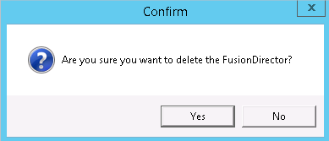

Click **OK**.

The FusionDirector is successfully deleted, as shown in Figure 3-13. In this window, you can check whether the target FusionDirector is deleted.

FusionDirector deleted successfully



----End

# Viewing Plug-in System Information

4.1 Viewing the Basic Plug-in System Information and Status

4.2 Viewing a Plug-in System Event List

4.3 Viewing a Plug-in System Alarm List

## Viewing the Basic Plug-in System Information and Status

Choose **Start** > > **Operations Console**.



The SCOM main window is displayed.

Choose **Monitoring** > **Huawei FusionDirector System** > **State View**.

The **State View** window is displayed, as shown in Figure 4-1.

State View

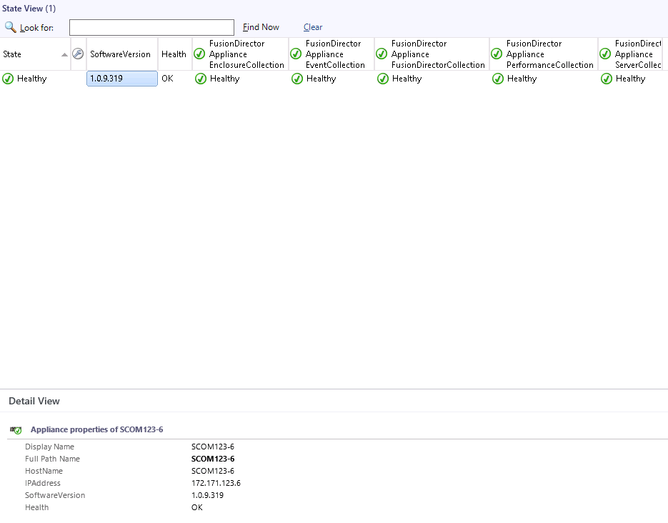

Each column in this window displays the running status of each function of the plug-in.

* **FusionDirector Appliance EnclosureCollection**: chassis monitoring function
* **FusionDirector Appliance EventCollection**: event monitoring function
* FusionDirector Appliance FusionDirectorCollection: FusionDirector monitoring function
* **FusionDirector Appliance PerformanceCollection**: performance curve monitoring function
* **FusionDirector Appliance ServerCollection**: server monitoring function

You can click anywhere in the row of the plug-in in the **State View** area to view details about the plug-in in the **Detail View** area.



The component health status is described as follows:

* : healthy



* : minor alarms



* : major or critical alarms



Set the parameters to be displayed.

1. Right-click a plug-in name or monitoring status and choose **Personalize View...** from the shortcut menu.

The **Personalize View** window is displayed, as shown in Figure 4-2.

Personalize View

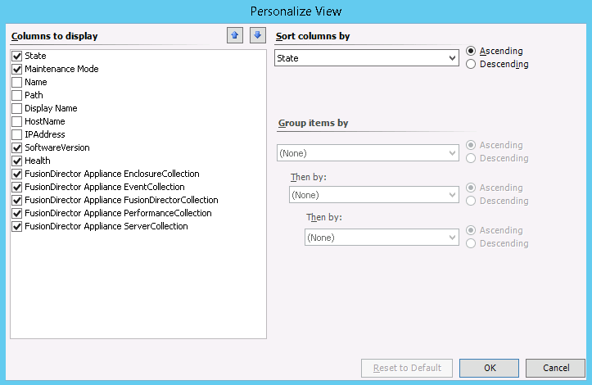

1. Select parameters to be viewed and click **OK**.

The parameters to be viewed are modified successfully.

----End

## Viewing a Plug-in System Event List

Choose **Start** > > **Operations Console**.



The SCOM main window is displayed.

Choose **Monitoring** > **Huawei FusionDirector System** > **Event View**.

The **Event View** window is displayed. You can click the event to be viewed to view the details of the event in the **Event Data** area, as shown in Figure 4-3.

Event View

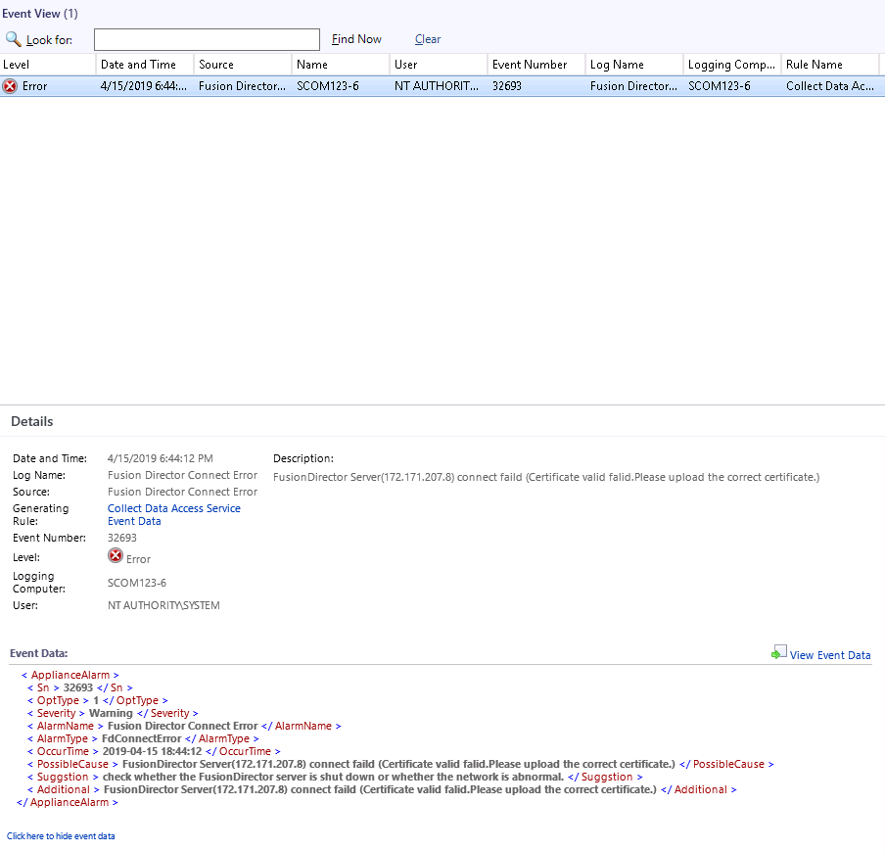

Table 4-1 describes the parameters.

Parameter description

| Parameter | Description |
| --- | --- |
| Level | Event type. The options are as follows:   * **Information**: running event * **Warning**: minor alarm * **Error**: major or critical alarm |
| Date and Time | Date and time when the event is generated. |
| Source | Event source, which is the component where the event is generated. |
| Name | Device where the event is generated. |
| User | Current user. |
| Event Number | Event number. |
| Log Name | Event name. |
| Logging Computer | Current login device. |
| Rule Name | Rule name. |

----End

## Viewing a Plug-in System Alarm List

Choose **Start** > > **Operations Console**.



The SCOM main window is displayed.

Choose **Monitoring** > **Huawei FusionDirector System** > **Alert View**.

The **Alert View** window is displayed. You can click an alarm to view its details, as shown in Figure 4-4.

Alert View

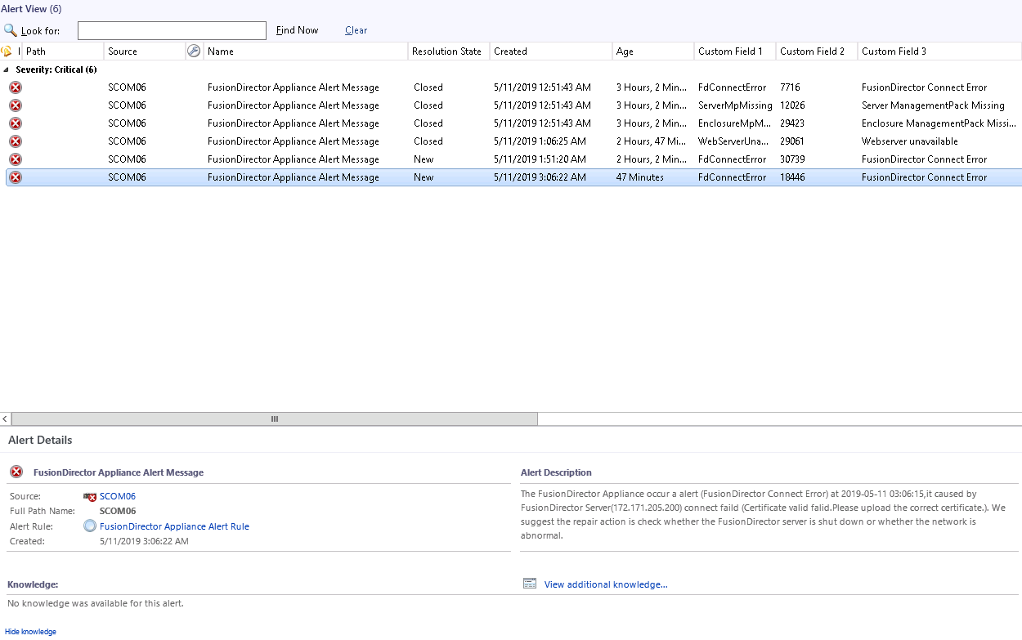

Table 4-2 describes the parameters.

Parameter description

| Parameter | Description |
| --- | --- |
| lcon | Alarm type. The options are as follows:   * **Warning**: minor alarm * **Critical**: major or critical alarm |
| Path | Sensor that generates the alarm. |
| Source | Device where the alarm is generated. |
| Maintenance Mode | Maintenance mode. |
| Name | Alarm name. |
| Resolution State | Handling status. |
| Created | Time when the alarm is generated. |
| Age | Duration of the alarm. |
| Owner | Owner. |
| Priority | Priority. |
| Latency | Latency. |
| Description | Alarm description. |
| Class | Alarm type. |
| Time in State | Alarm duration. |
| Repeat Count | Number of repeated occurrence times. |
| Custom Field 1 | Alarm type. |
| Custom Field 2 | Alarm code. |
| Custom Field 3 | Alarm name. |
| Custom Field 4 | Possible cause. |
| Custom Field 5 | Remarks. |
| Custom Field 6 | Alarm clearance suggestion. |
| Custom Field 7 | Alarm occurrence time. |

----End

# Viewing Chassis Information

5.1 Viewing the Basic Chassis Information and Status

5.2 Viewing a Chassis Topology

5.3 Viewing a Chassis Alarm List

## Viewing the Basic Chassis Information and Status

Choose **Start** > > **Operations Console**.



The SCOM main window is displayed.

Choose **Monitoring** > **Huawei FusionDirector System** > **Huawei Enclosures** > **State View**.

The **State View** window is displayed, as shown in Figure 5-1. In this window, the managed chassis are displayed in different rows and monitoring parameters of chassis are displayed in different columns.

State View

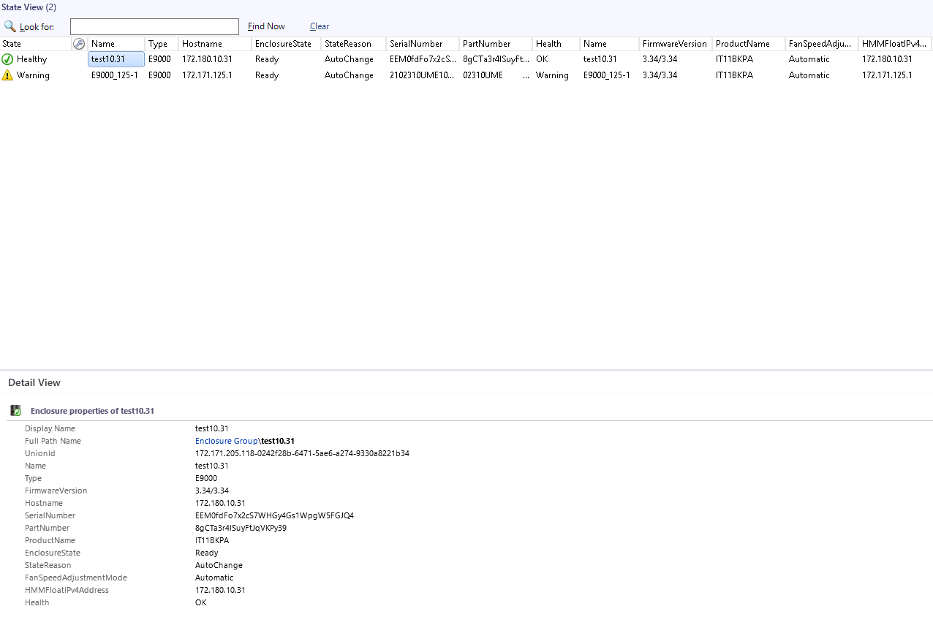

In the **State View** area, you can click any position in the row of a chassis to view details about the chassis in the **Detail View** area.



The chassis health status is described as follows:

* : healthy



* : minor alarms



* : major or critical alarms



Set the parameters to be displayed.

1. Right-click a chassis name and choose **Personalize View...** from the shortcut menu.

The **Personalize View** window is displayed, as shown in Figure 5-2.

Personalize View

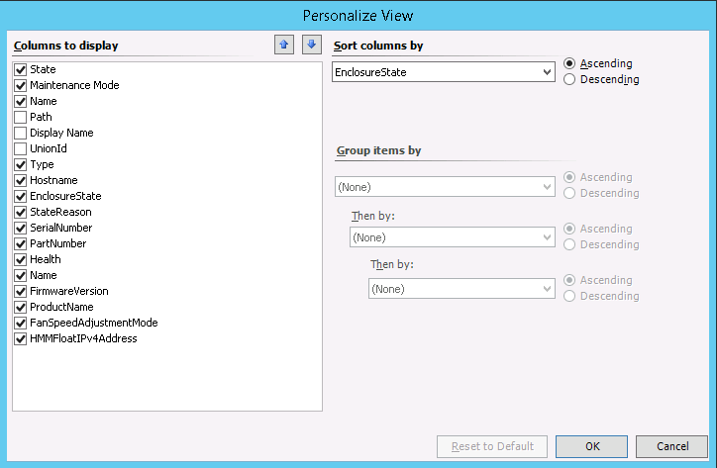

1. Select parameters to be viewed and click **OK**.

The parameters to be viewed are modified successfully.

Table 5-1 describes the parameters that can be viewed by the Huawei SCOM plug-in.

Components and parameters that can be viewed

| Parameter | Description |
| --- | --- |
| State | Chassis presence status. |
| Name | Server name. |
| Type | Server model. |
| Hostname | Host name. |
| StateReason | Reason of the chassis presence status. |
| SerialNumber | Serial number. |
| PartNumber | Component number. |
| Health | Chassis health status. |
| FirmwareVersion | HMM version. |
| ProductName | Product name. |
| FanSpeedAdjustmentMode | Fan speed adjustment mode. |
| HMMFloatIPv4Address | HMM floating IP address. |

----End

## Viewing a Chassis Topology

Choose **Start** > > **Operations Console**.



The SCOM main window is displayed.

Choose **Monitoring** > **Huawei FusionDirector System** > **Huawei Enclosures** > **Diagram View**.

The **Diagram View** window is displayed, as shown in Figure 5-3.

Diagram View

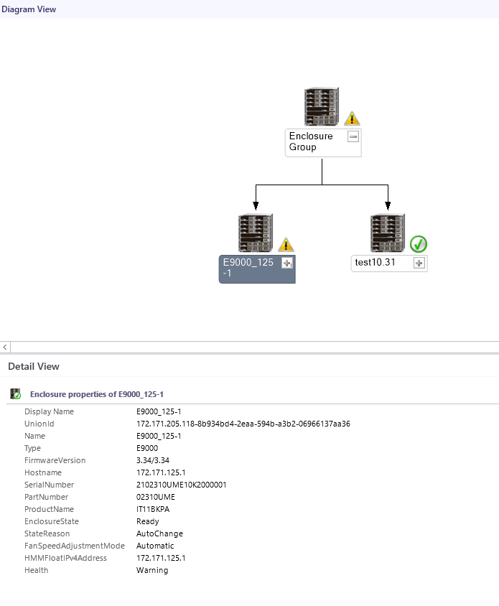

If the topology is not refreshed in time, you can perform the following steps to refresh it:

Open the CLI of the SCOM server.

Access the SCOM installation path (**C:\Program Files\System Center Operations Manager 2012\Console**) on the CLI.

Run the following command to refresh the SCOM window:

**Microsoft.EnterpriseManagement.Monitoring.Console.exe" /clearcache**

----End

## Viewing a Chassis Alarm List

Choose **Start** > > **Operations Console**.



The SCOM main window is displayed.

Choose **Monitoring** > **Huawei FusionDirector System** > **Huawei Enclosures** > **Alert View**.

In the **Alert View** window that is displayed, click an alarm to view its details, as shown in Figure 5-4.



The FusionDirector that is added for the first time synchronously displays historical alarms that are not cleared.

Alert View

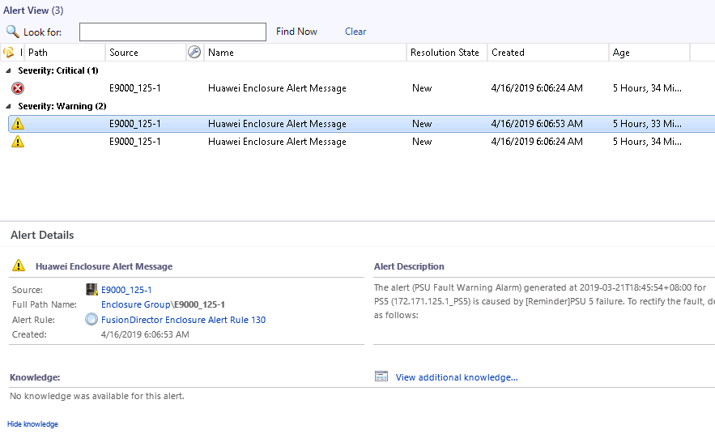

Table 5-2 describes the parameters.

Parameter description

| Parameter | Description |
| --- | --- |
| lcon | Alarm type. The options are as follows:   * **Warning**: minor alarm * **Critical**: major or critical alarm |
| Path | Sensor that generates the alarm. |
| Source | Device where the alarm is generated. |
| Maintenance Mode | Maintenance mode. |
| Name | Alarm name. |
| Resolution State | Handling status. |
| Created | Time when the alarm is generated. |
| Age | Duration of the alarm. |
| Owner | Owner. |
| Priority | Priority. |
| Latency | Latency. |
| Description | Alarm description. |
| Class | Alarm type. |
| Time in State | Alarm duration. |
| Repeat Count | Number of repeated occurrence times. |

----End

# Viewing Server Information

6.1 Viewing the Basic Server Information and Status

6.2 Viewing a Server Topology

6.3 Viewing a Server Alarm List

6.4 Viewing Server Performance Curves

## Viewing the Basic Server Information and Status

Choose **Start** > > **Operations Console**.



The SCOM main window is displayed.

Choose **Monitoring** > **Huawei FusionDirector System** > **Huawei Servers** > **State View**.

The **State View** window is displayed, as shown in Figure 6-1. In this window, the managed servers are displayed in different rows and status monitoring parameters of monitored components on each server are displayed in different columns.

State View

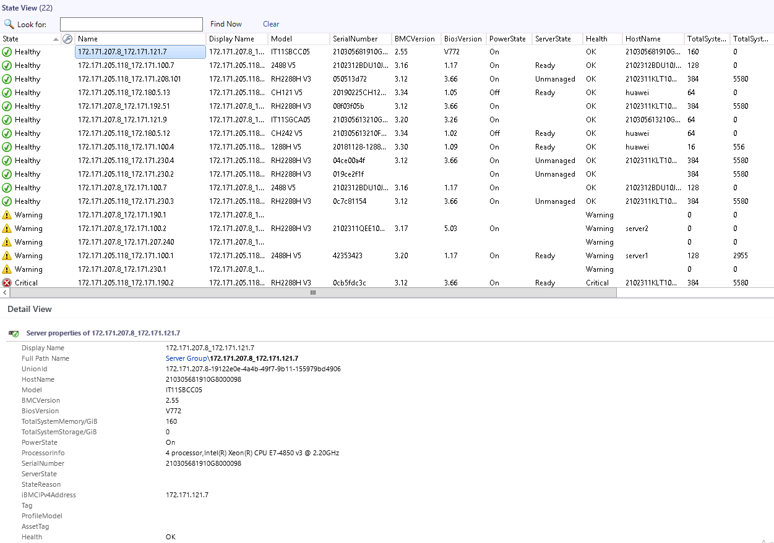

In the **State View** area, you can click any position in the row of a server to view details about the server in the **Detail View** area.



The server health status is described as follows:

* : healthy



* : minor alarms



* : major or critical alarms



Set the parameters to be displayed. For details, see Step 3 in 5.1 Viewing the Basic Chassis Information and Status.

Table 6-1 describes server parameters that can be monitored by the Huawei SCOM plug-in.

Parameter description

| Parameter | Description |
| --- | --- |
| State | Server presence status. |
| Model | Server model. |
| SerialNumber | Serial number. |
| Tag | Server tag. |
| AssetTag | Asset tag. |
| BMCVersion | iBMC version. |
| BiosVersion | BIOS version. |
| PowerState | Power status. |
| Health | Server health status. |
| HostName | Host name. |
| TotalSystemMemory/GiB | Memory size. |
| TotalSystemStorage/GiB | Storage size. |
| ProcessorInfo | CPU information. |
| StateReason | Reason of the server presence status. |
| iBMCIPv4Address | iBMC IP address. |
| ProfileModel | Configuration file type. |
| UUID | UUID |

----End

## Viewing a Server Topology

Choose **Start** > > **Operations Console**.



The SCOM main window is displayed.

Choose **Monitoring** > **Huawei FusionDirector System** > **Huawei Servers** > **Diagram View**.

The **Diagram View** window is displayed, as shown in Figure 6-2.

Diagram View

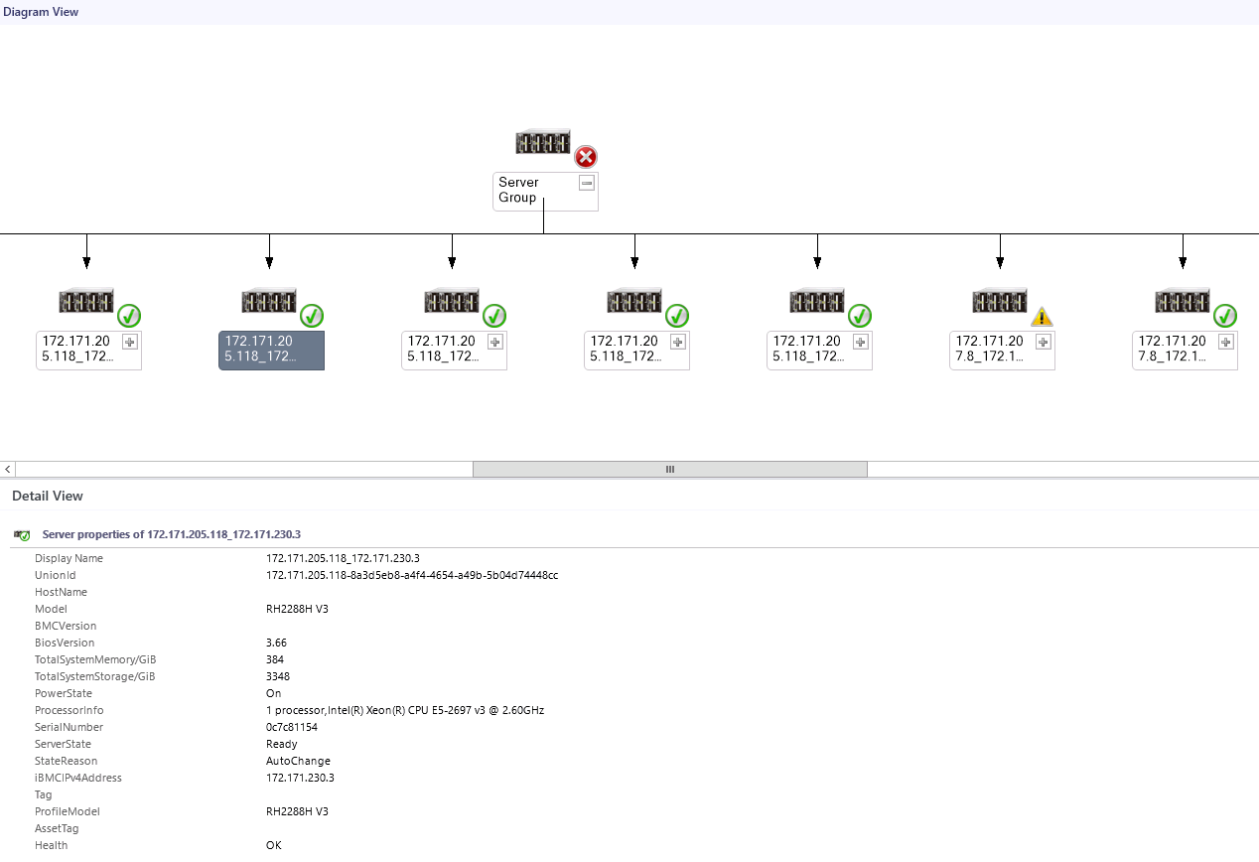

If the topology is not refreshed in time, you can perform the following steps to refresh it:

Open the CLI of the SCOM server.

Access the SCOM installation path (**C:\Program Files\System Center Operations Manager 2012\Console**) on the CLI.

Run the following command to refresh the SCOM window:

**Microsoft.EnterpriseManagement.Monitoring.Console.exe" /clearcache**

----End

## Viewing a Server Alarm List

Choose **Start** > > **Operations Console**.



The SCOM main window is displayed.

Choose **Monitoring** > **Huawei FusionDirector System** > **Huawei Servers** > **Alert View**.

In the **Alert View** window that is displayed, click an alarm to view its details, as shown in Figure 6-3.



The FusionDirector that is added for the first time synchronously displays historical alarms that are not cleared.

Alert View

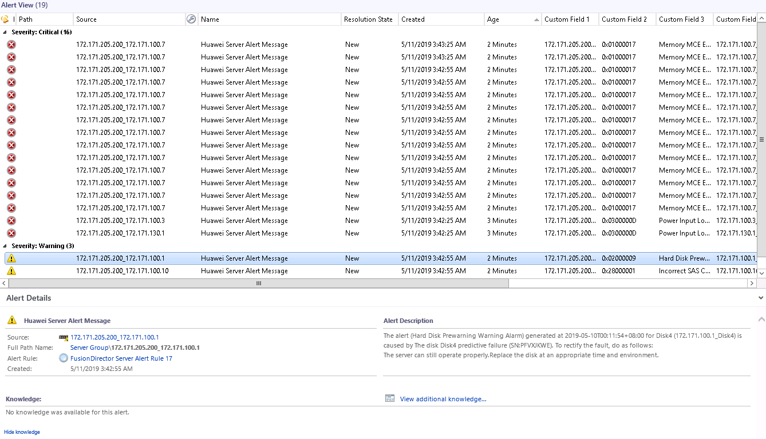

Table 6-2 describes the parameters.

Parameter description

| Parameter | Description |
| --- | --- |
| lcon | Alarm type. The options are as follows:   * **Warning**: minor alarm * **Critical**: major or critical alarm |
| Path | Sensor that generates the alarm. |
| Source | Device where the alarm is generated. |
| Maintenance Mode | Maintenance mode. |
| Name | Alarm name. |
| Resolution State | Handling status. |
| Created | Time when the alarm is generated. |
| Age | Duration of the alarm. |
| Owner | Owner. |
| Priority | Priority. |
| Latency | Latency. |
| Description | Alarm description. |
| Class | Alarm type. |
| Time in State | Alarm duration. |
| Repeat Count | Number of repeated occurrence times. |

----End

## Viewing Server Performance Curves

You can view performance curves only of servers whose **ServerState** is **Ready**.

### Viewing the CPU Usage

Choose **Start** > > **Operations Console**.



The SCOM main window is displayed.

Choose **Monitoring** > **Huawei FusionDirector System** > **Huawei Servers** > **Performance View** > **CPU Usage(%)**.

The **CPU Usage(%)** window is displayed, as shown in Figure 6-4.

CPU Usage(%)

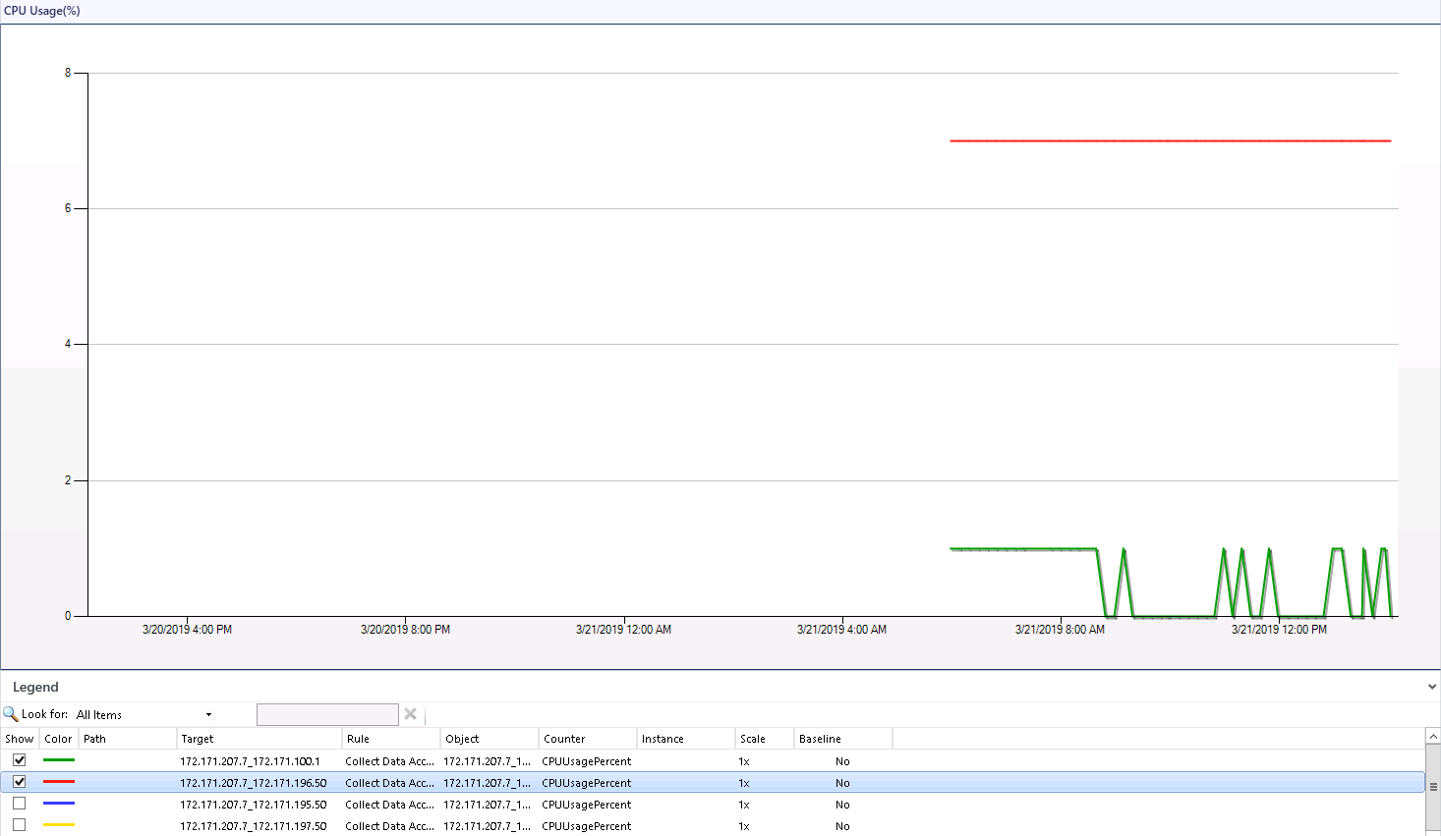

Select servers in the **Legend** area to view the CPU usage curves of the servers.

----End

### Viewing the Air Inlet Temperature

Choose **Start** > > **Operations Console**.



The SCOM main window is displayed.

Choose **Monitoring** > **Huawei FusionDirector System** > **Huawei Servers** > **Performance View** > **Inlet Temp(Centigrade)**.

The **Inlet Temp(Centigrade)** window is displayed, as shown in Figure 6-5.

Inlet Temp(Centigrade)

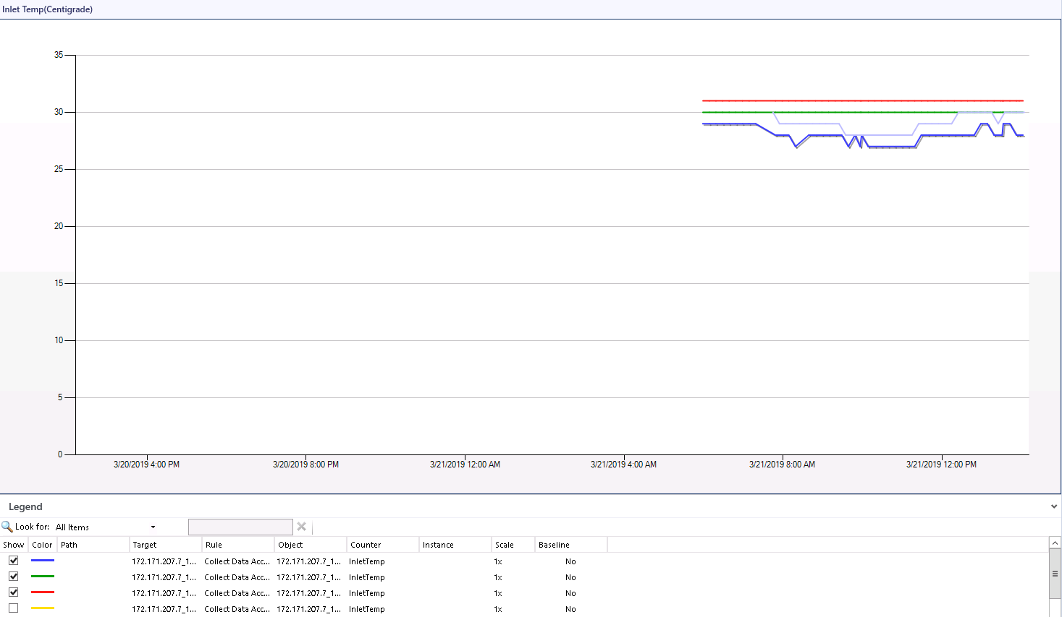

Select servers in the **Legend** area to view the air inlet temperature curves of the servers.

----End

### Viewing the PSU Power

Choose **Start** > > **Operations Console**.



The SCOM main window is displayed.

Choose **Monitoring** > **Huawei FusionDirector System** > **Huawei Servers** > **Performance View** > **Power Consumed(Watts)**.

The **Power Consumed(Watts)** window is displayed, as shown in Figure 6-6.

Power Consumed(Watts)

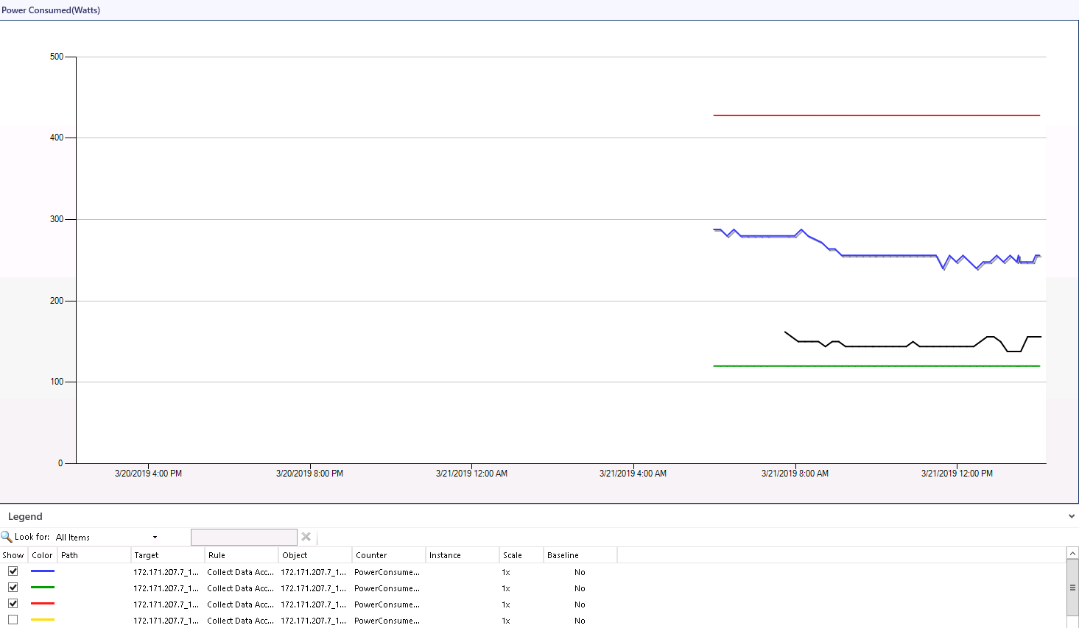

Select servers in the **Legend** area to view the PSU power curves of the servers.

----End

# FAQs

7.1 How Do I Fix a Communication Failure Caused by an Incorrect Default FusionDirector Certificate?

7.2 How Do I Replace the Server Certificate?

## How Do I Fix a Communication Failure Caused by an Incorrect Default FusionDirector Certificate?

Symptom

If the default FusionDirector certificate is modified or replaced after this plug-in is added to FusionDirector, the plug-in fails to communicate with FusionDirector.

Solution

Manually upload the modified or replaced Fusion Director certificate. The following procedure uses upload of the FusionDirector certificate as an example.

* Uploading the Root Certificate
  1. Double-click the root certificate **HuaweiEquipmentRootCA** of Huawei FusionDirector.

The **Certificate** window is displayed, as shown in Figure 7-1.

Certificate

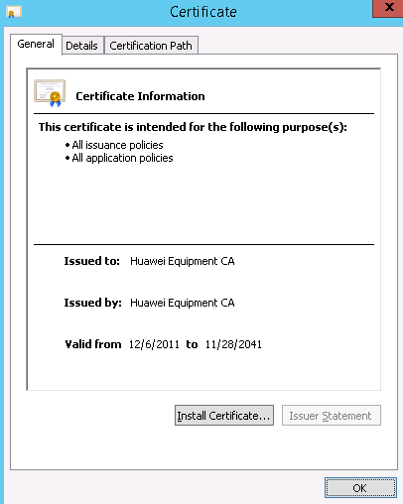

* 1. Click **Install Certificate...**.

The **Certificate Import Wizard** window is displayed, as shown in Figure 7-2.

Certificate Import Wizard

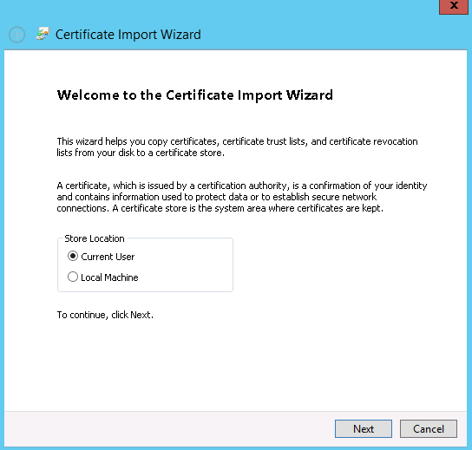

* 1. Select **Local Machine** and click **Next**.

The **Certificate Store** window is displayed, as shown in Figure 7-3.

Certificate Stone

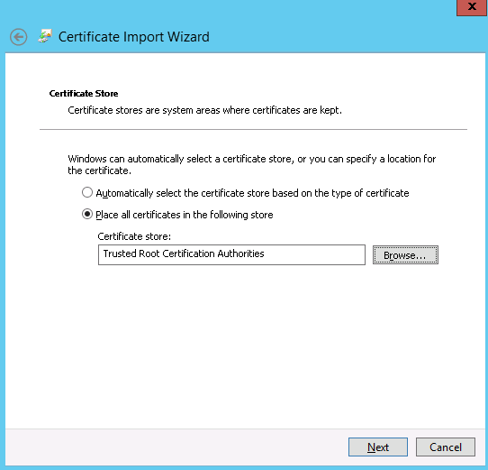

* 1. Select **Place all Certificates in following store**.
  2. Click **Browse…**, select **Trusted Root Certification Authorities**, and click **Next**.

The **Completing the Certificate Import Wizard** window is displayed, as shown in Figure 7-4.

Completing the Certificate Import Wizard

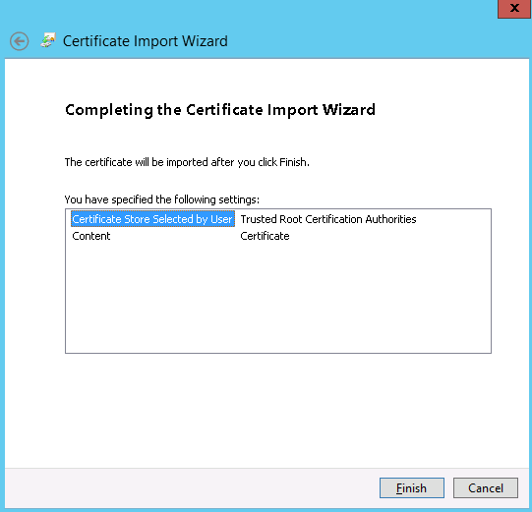

* 1. Click **Finish**.

A dialog box indicating import success is displayed, as shown in Figure 7-5.

Import success

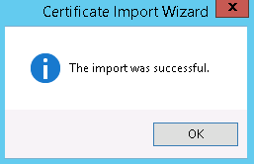

* 1. Click **OK**.
  2. On the Figure 7-1 page, click **OK**. The certificate is imported.
* Uploading the Product Certificate
  1. Double-click the product certificate **HuaweiITProductCA** of Huawei FusionDirector.

The **Certificate** window is displayed, as shown in Figure 7-6.

Certificate

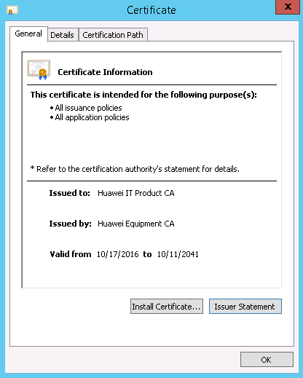

* 1. Click **Install Certificate...**.

The **Certificate Import Wizard** window is displayed, as shown in Figure 7-7.

Certificate Import Wizard



* 1. Select **Local Machine** and click **Next**.

The **Certificate Store** window is displayed, as shown in Figure 7-8.

Certificate Store

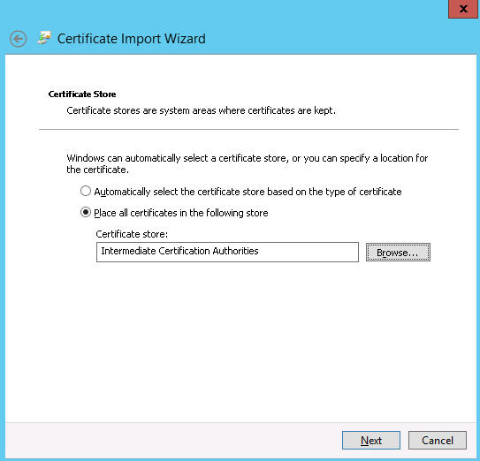

* 1. Select **Place all Certificates in following store**.
  2. Click **Browse…**, select **Intermediate Certification Authorities**, and click **Next**.

The **Completing the Certificate Import Wizard** window is displayed, as shown in Figure 7-9.

Completing the Certificate Import Wizard

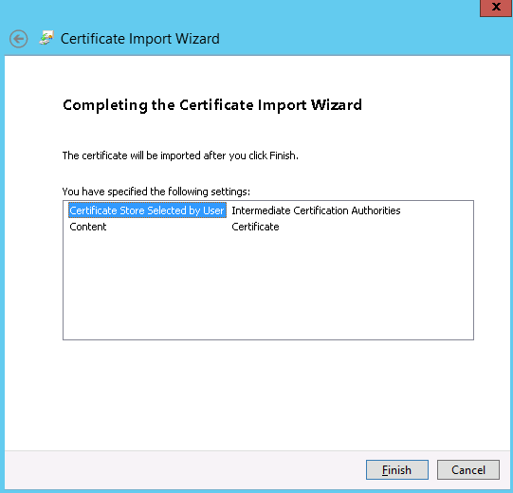

* 1. Click **Finish**.

A dialog box indicating import success is displayed, as shown in Figure 7-10.

Import success



* 1. Click **OK**.
  2. On the Figure 7-6 page, click **OK**. The certificate is imported.

## How Do I Replace the Server Certificate?

Import the root certificate on the FusionDirector WebUI.

1. Choose **System Settings** > **Security** > **Certificates**. The **Certificate** page is displayed, as shown by (1) in Figure 7-11.

Importing the root certificate

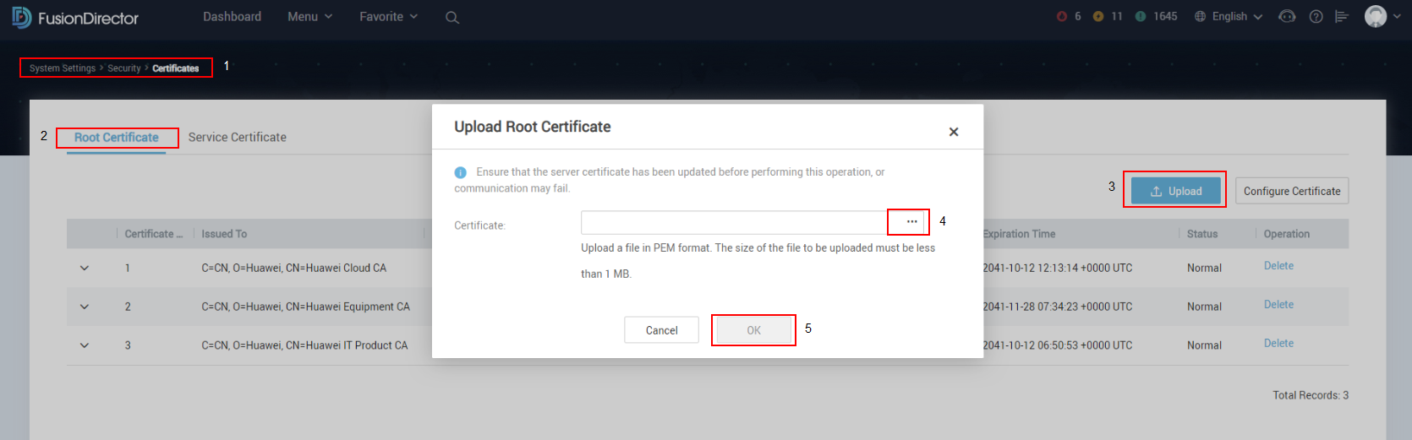

1. Choose **Root Certificate**, as shown by (2) in Figure 7-11.
2. On the **Root Certificate** page, click **Upload**, as shown by (3) in Figure 7-11.

The **Upload Root Certificate** dialog box is displayed.

1. Select the root certificate to be imported and click **OK**, as shown by (4) and (5) in Figure 7-11.

In the SCOM plug-in environment, save the server certificate to be imported to the following path, as shown in Figure 7-12.

**C:\Program Files\Huawei Fusion Director For SCOM plugin\Certs**

Certificate path

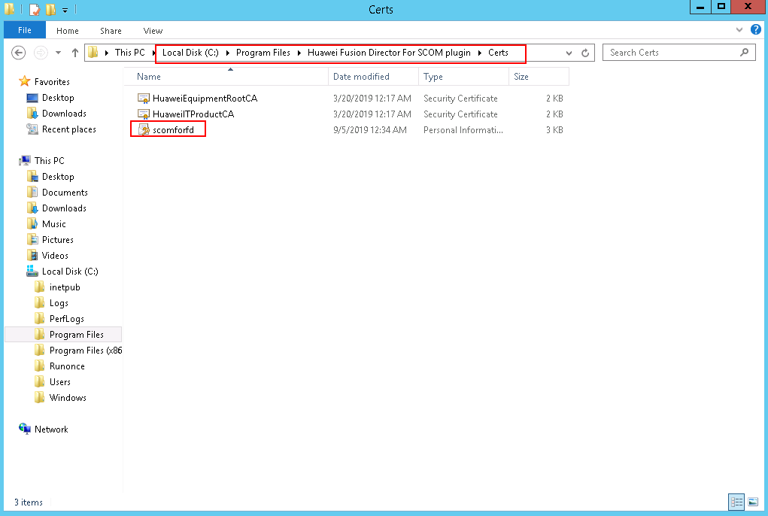

Double-click the certificate to start the installation.

The **Welcome to the Certificate Import Wizard** page is displayed, as shown in Figure 7-13.

Welcome to the Certificate Import Wizard page

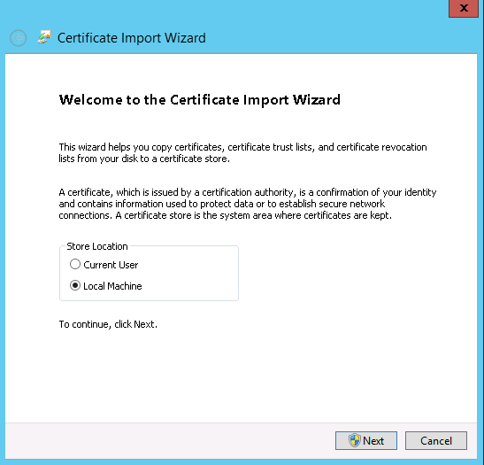

Select **Local Machine** and click **Next**.

The **File to Import** page is displayed, as shown in Figure 7-14.

File to Import page

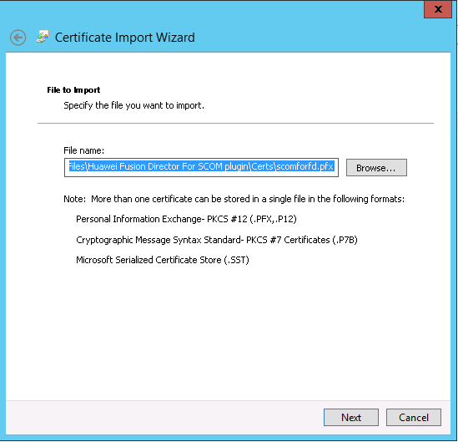

Retain the default file path and click **Next**.

The **Private key protection** page is displayed, as shown in Figure 7-15.

Private key protection page

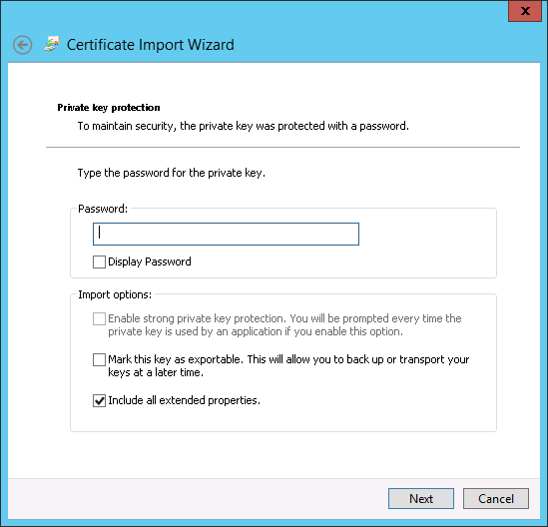

Enter the password (which is set by the user during certificate generation) and click **Next**.

The **Certificate Store** page is displayed, as shown in Figure 7-16.

Certificate Store page 1

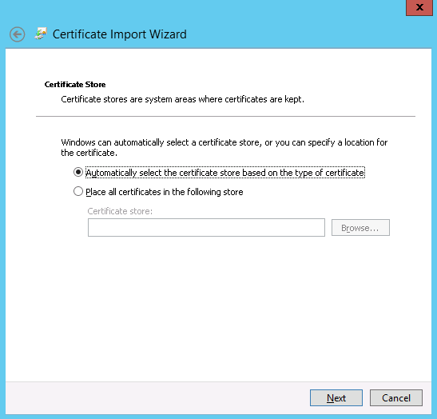

On the **Certificate Store** page:

1. Select **Place all certificates in the following store**, as shown by (1) in Figure 7-17.

Certificate Store page 2

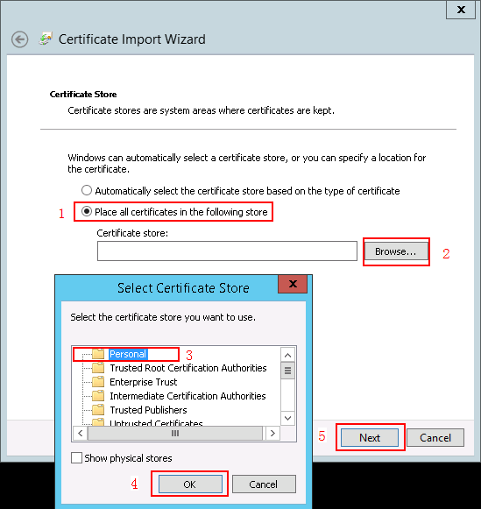

1. Click **Browse**, as shown by (2) in Figure 7-17.

The **Select Certificate Store** dialog box is displayed.

1. Select Personal, as shown by (3) in Figure 7-17.
2. Click **OK**, as shown by (4) in Figure 7-17.
3. Click **Next**, as shown by (5) in Figure 7-17.

The **Completing the Certificate Import Wizard** page is displayed, as shown in Figure 7-18.

Completing the Certificate Import Wizard page

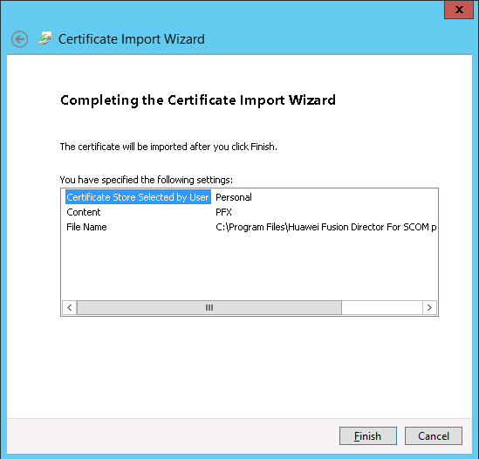

Click **Finish** to import the certificate.

A dialog box is displayed indicating that the certificate is successfully imported, as shown in Figure 7-19.

Imported successfully



Click **OK**.

Run the following command to delete the existed certificate:

**netsh http delete sslcert ipport=0.0.0.0:***Port*



*Port* indicates the port number set during the SCOM plug-in installation.

For example, run the following command:

**netsh http delete sslcert ipport=0.0.0.0:44301**

The "SSL Certificate successfully deleted" information is returned, as shown in Figure 7-20.

Returned information 1

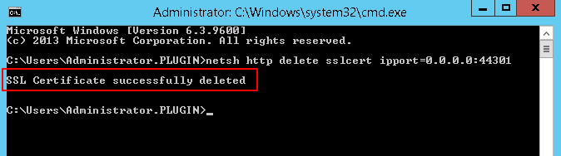

Copy the certificate thumbprint.

1. In the server certificate list, locate and open the page for manually importing the certificate.
2. On the **Details** tab page, find and click **Thumbprint**.
3. Copy the displayed certificate fingerprint, as shown in Figure 7-21.

Copying the certificate thumbprint

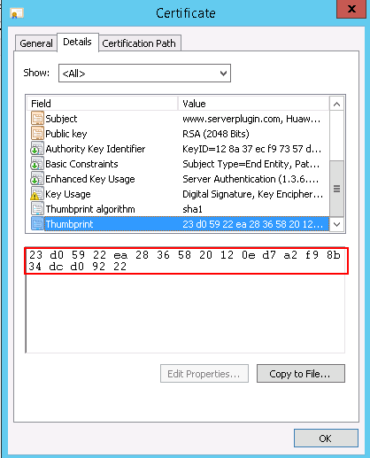

Run the following command to replace the certificate:

**netsh http add sslcert ipport=0.0.0.0:***Port* **certhash=***Thumbprint* **appid={214124cd-d05b-4309-9af9-9caa44b2b74a}**



* *Port* indicates the port number set during the SCOM plug-in installation.
* The spaces in the certificate thumbprint must be deleted.

For example, run the following command:

**netsh http add sslcert ipport=0.0.0.0:44301 certhash=23d05922ea28365820120ed7a2f98b34dcd09222 appid={214124cd-d05b-4309-9af9-9caa44b2b74a}**

The "SSL Certificate successfully added" information is returned, as shown in Figure 7-22.

Returned information 2



Restart the service.

1. Open **Task Manager**.
2. On the **Services** tab page, find **Huawei Fusion Director For SCOM plugin Service**, as shown in Figure 7-23.

Restarting the service 1

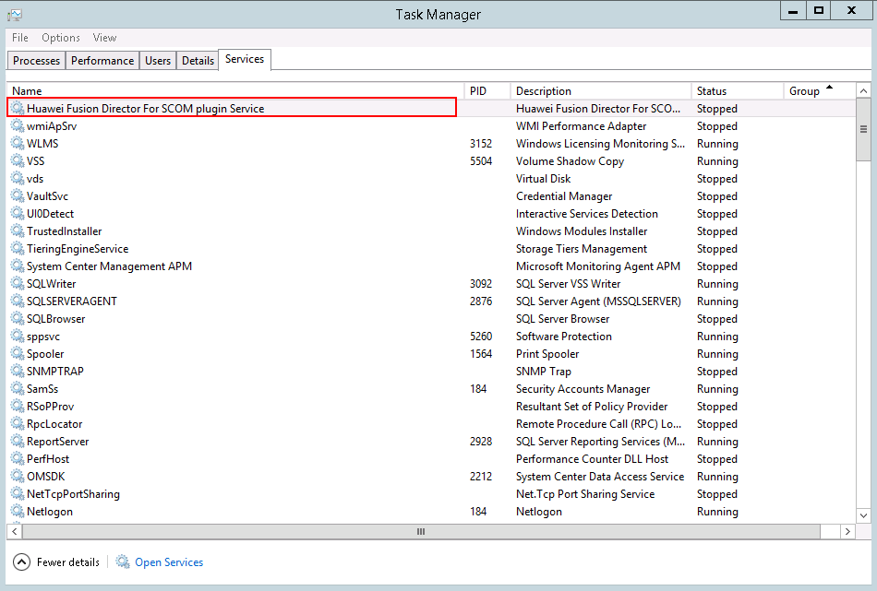

1. Right-click the service and choose **Restart** to restart the service, as shown in Figure 7-24.

Restarting the service 2

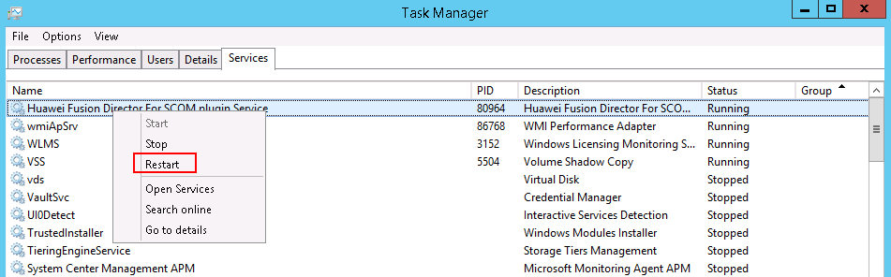

----End

1. Glossary

E

|  |  |
| --- | --- |
| **eSight** | eSight is a platform related to Huawei server management. |

N

|  |  |
| --- | --- |
| **NetFramework** | Microsoft .NET Framework is a new hosting code programming model used for Windows. It combines powerful functions with new technologies to construct applications with excellent user experience, implement seamless communications across technical boundaries, and support various service processes. |

S

|  |  |
| --- | --- |
| **SCOM** | System Center Operation Manager (SCOM) refers to the Microsoft system center operation manager. SCOM monitors servers, application systems, and clients in the network. It provides a GUI for administrators to monitor faults and alarms of target computers. |